Collège Pierre-Elliott-Trudeau
Varsity Boys Basketball Tournament
February 8th and 9th

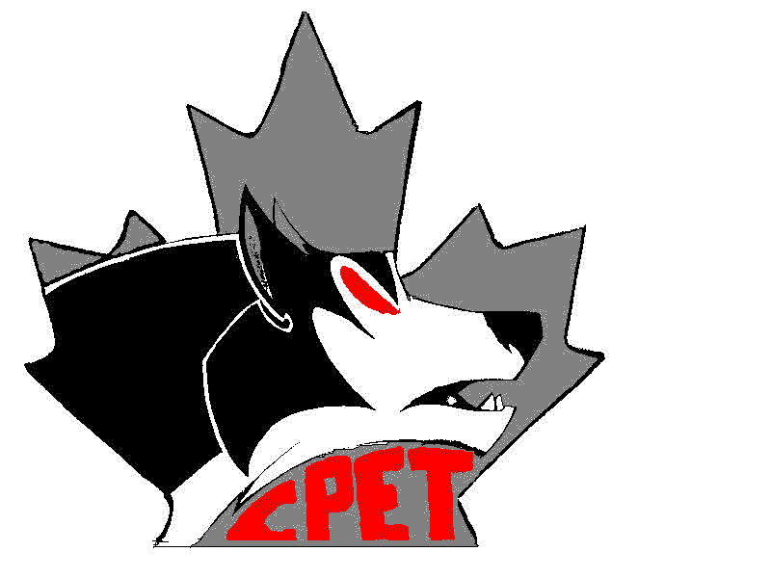

Time

Game 1: CPET vs CC 4:00 pm on Friday Feb 8th

Game 2: PCI vs SCA 5:30 pm on Friday Feb 8th

Game 3: CPET vs SCA 9:00 am on Saturday Feb 9th

Game 4: PCI vs CC 10:30 am on Saturday Feb 9th

Game 5: CC vs SCA 2:00 pm on Saturday Feb 9th

Game 6: CPET vs PCI 3:30 pm on Saturday Feb 9th

Information
1. Location: Collège Pierre-Elliott-Trudeau 216 Redonda St

2. Parking: Behind the school

3. Entry Fee: $200.00 per team, cheques payable to CPET

4. Format: 4 teams – 3 games each round robin format

5. Game Regulations:
- 4 –10 minute quarters (stop time)
- 5 minute halftime
- 2 – 60 second timeouts 1st half and 2 – 60 second timeouts 2nd half
- 5 minute overtime to break ties, only 1 full timeout in each overtime
- 8 minute warm up before each game, time permitting
- 3 point line is in effect
- Penalty is awarded on the 5th team foul of each quarter
- Teams that are ahead by 30 points or more will forfeit the right to press in the second half
- There is a 24 sec. shot clock
- A victory awards a team one point, 3 points = 1st place, 2 points = second place, etc
- In the event of a tie the team with the most points scored during the tournament will win.
- If the total point scored for two teams is equal the team with the least points against will win.

6. Awards: Champion & 2nd Place

7. Change Rooms: Please keep the change rooms clean. Keep your belongings with you.

