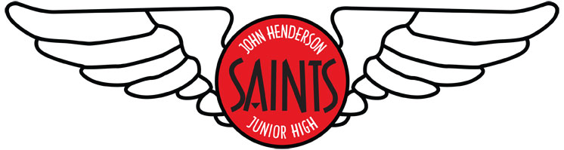

John Henderson Junior High

Grade 8 Boys

Basketball Tournament Info and Rules

Location: ÉCOLE JOHN HENDERSON SCHOOL
930 BRAZIER STREET
WINNIPEG, MB R2K 2P3
TELEPHONE: 204-661-2503 FAX: 204-668-9353

Tournament date: Feb. 1 & 2, 2013
Participating Teams:
John Henderson |  | Shamrock
Arthur Day |  | John W. Gunn
Salisbury Morse Place |  | H C Avery
Samuel Burland |  | Calvin Christian

Tournament fee: $140.00 made payable to ÉCOLE JOHN HENDERSON SCHOOL

Contact: Patricia Tomczyk ptomczyk@retsd.mb.ca

Additional Information: - Coaches hospitality room
- Please help keep our gym tidy and place all garbage in trash cans. Please communicate this to your players and their parents.

John Henderson
Grade 8 Boys Tournament
930 Brazier Street
(204)-661-2503
 |  |  | February 1st and 2nd
 |  |  | John Henderson
 |  |  | 4:00 p.m.
 |  |  | Fri. Feb 1st
 |  |  | Arthur Day
 |  | 9:00 a.m. |  | 12:00 p.m.
 |  | Sat. Feb 2nd | SMP | Sat. Feb 2nd
 |  |  | 5:30 p.m.
 |  |  | Fri. Feb 1st
 |  |  | Samuel Burland
 | 4:30 p.m. |  |  |  | 7:30 p.m.
 | Sat. Feb 2nd |  | Shamrock |  | Sat. Feb 2nd
 |  |  | 7:00 p.m.
 |  |  | Fri. Feb 1st
 |  |  | JWG
 |  | 10:30 a.m. |  | 1:30 p.m.
 |  | Sat. Feb 2nd | HC Avery | Sat. Feb 2nd
 |  |  | 8:30 p.m.
 |  |  | Fri. Feb 1st
 |  |  | Calvin Christian
 | 3:00 p.m. |  |  |  | 6:00 p.m.
 | Sat. Feb 2nd |  |  |  | Sat. Feb 2nd

John Henderson Junior High

Rules and Regulations

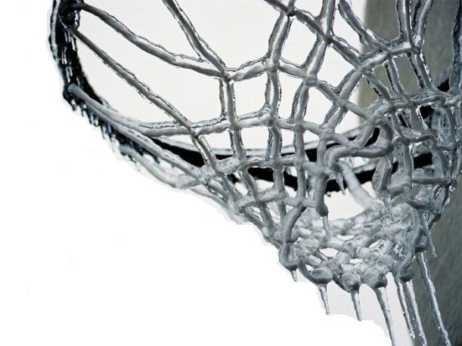

- All games are to be played in 4 quarters of 8 minutes
- Five minute half time (time permitting)
- Full court press up to 15 points
- 3 point line is in effect
- FIBA key to be used
- Man-to-Man defense. Zone or zone-pressing types of defense are not permitted
- Temporary double teaming on the ball is allowed
- No shot clock
- No clear out offences
- Bonus will be awarded at the 5th foul of each quarter
- Two time outs in the first half and three for the second half
- Time outs to be requested by coach at any stoppage in play
- If the game is tied after regulation, an overtime of 3 minutes will be played, with one time out.

